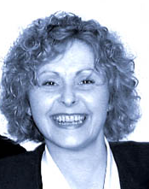

Mrs Selina Maxwell, co-owner of Car Care Garage

